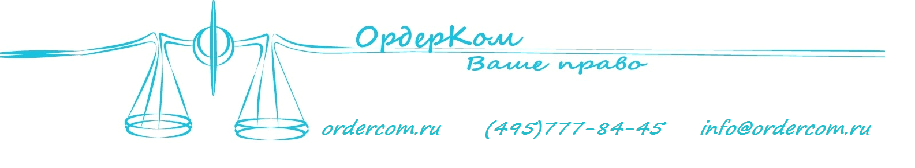
OrderCom is a limited liability company under the Russian legislation that specializes on right protection and legal consulting of businesses on the issues of different aspects of communication industry. The head of the company is the Director General Dmitriy Galushko, candidate of science (law), graduate of the Moscow State Academy of Law and member of advisory board of the Federal Antimonopoly Service of the Russian Federation.
The company was formed in 2008 but its leading force represented by DG Dmitriy Galushko and CEO Ivan Galushko has been successfully representing interests of communications service providers since 2002.
Today our crew holds key position in consulting on telecom’s legal issues.
The employees of the company frequently publish their opinions and legal reviews in cross media sources, e.g. comnews.ru, cableman.ru, official journal of Federal Supervision Agency for Information Technologies and Communications and some other federal newspapers.
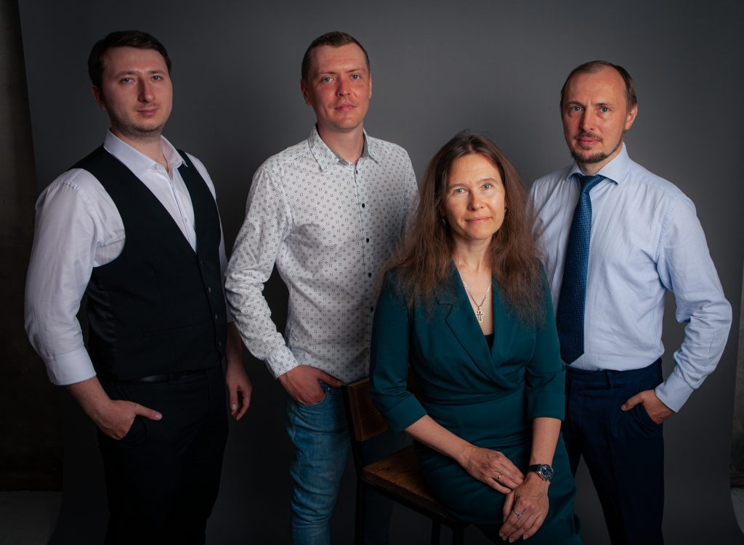
During the professional career our team has gained expertise in working group set up by the Ministry of Communications and Mass Media of the Russian Federation, initiated a number of significant draft laws, has been building up landmark judicial decisions and effectively communicating with all important public authorities of the industry, including Federal Security Service and Federal Antimonopoly Service of the Russian Federation.
More than 5 000 telecommunication licenses have been obtained with our help, over than 300 000 number pools were received all over the Russian Federation. Looking forward we have engaged specialists from developing areas of law, such as personal data security and public procurements.
Hundreds of clients have been using our services, including PJSC VimpelCom, Mail.ru, LifeNews, Level3, LynxTelecommunication, AltegroSky, SipNet etc.
Should you have any questions – feel free to contact us by e-mail (info@ordercom.ru) or phone (+7 (495) 642-73-77). To get more information about us you can check our web-site – www.ordercom.ru.
Thank you for your attention!

